Experiment - 1
Operating Systems Lab
Syeda Reeha Quasar
14114802719
6C7
AIM
Write a program to implement CPU scheduling for first come first serve.

EXPERIMENT – 1

Aim:
Write a program to implement CPU scheduling for first come first serve.

Theory:
The first come first serve (FCFS) scheduling algorithm simply schedules the jobs according to their arrival time. The job which comes first in the ready queue will get the CPU first. The lesser the arrival time of the job, the sooner will the job gets the CPU. FCFS scheduling may cause the problem of starvation if the burst time of the first process is the longest of all the jobs.

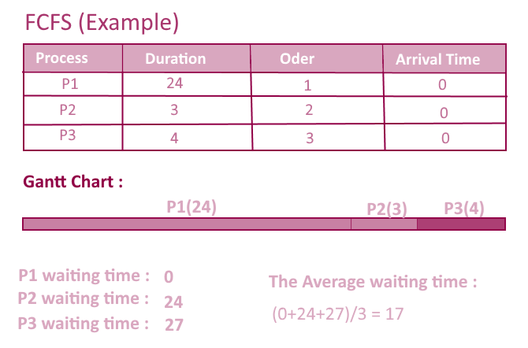
Computation:
- Completion Time: Time at which process completes its execution.
- Turn Around Time: Time Difference between completion time and arrival time. Turn Around Time = Completion Time – Arrival Time
- Waiting Time(W.T): Time Difference between turn around time and burst time.
Waiting Time = Turn Around Time – Burst Time

Algorithm:
1- Input the processes along with their burst time (bt).
2- Find waiting time (wt) for all processes.
3- As first process that comes need not to wait so
waiting time for process 1 will be 0 i.e. wt[0] = 0.
4- Find waiting time for all other processes i.e. for
process i ->
wt[i] = bt[i-1] + wt[i-1] .
5- Find turnaround time = waiting_time + burst_time
for all processes.
6- Find average waiting time =
total_waiting_time / no_of_processes.
7- Similarly, find average turnaround time =
total_turn_around_time / no_of_processes.

Source Code:

process=("p1" "p2" "p3" "p4" "p5")
bt=(0 0 0 0 0)
wt=(0 0 0 0 0)
tat=(0 0 0 0 0)

bt[0]=1
factor=0
wtSum=0
tatSum=0

echo "We will be using FCFS for 5 processes"

for ((i=0; i<5; i++))
do
echo "Enter burst time for process ${process[i]}"
read ele
bt[i]=$ele
wt[i]=$factor
factor=$((factor + ele))
tat[i]=$((bt[i] + wt[i]))
wtSum=$((wt[i] + wtSum))
tatSum=$((tat[i] + tatSum))
done

echo ""
echo "Process | Burst Time | Wait Time | Turn Around Time"

for ((i=0; i<5; i++))
do
echo "${process[i]} | ${bt[i]} | ${wt[i]} | ${tat[i]}"
done

echo ""
echo "Average waiting time = $((wtSum/5))"
echo "Average turn around time = $((tatSum/5))"

Output:

